Comp 3007 Assignment #4

Alyxander-Jacob Ricketts

101084146

Question 1a)

Question 1b)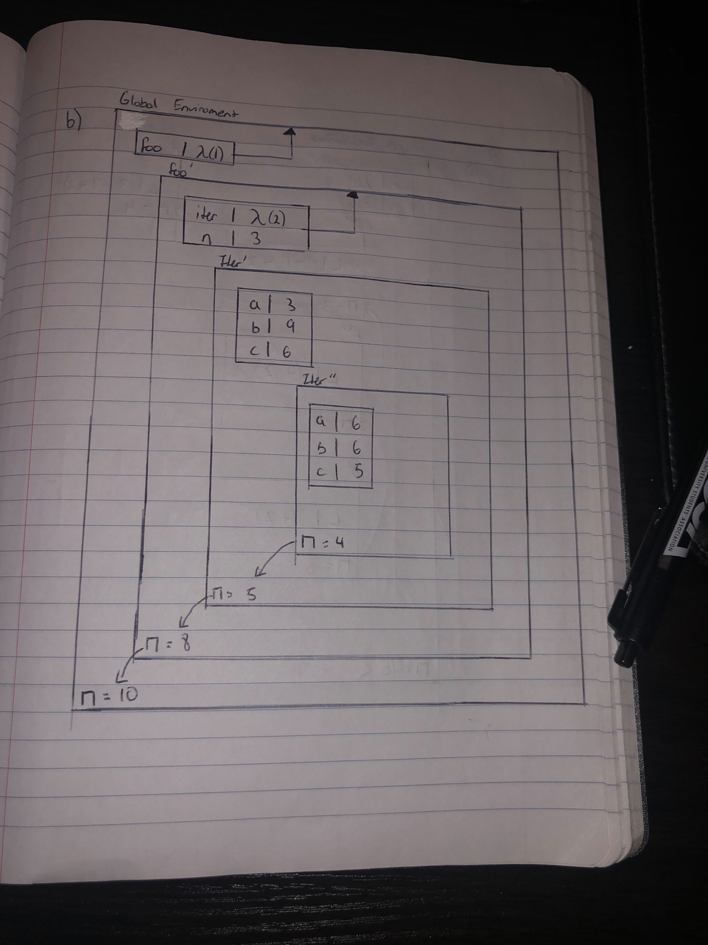

Question 2a)

Question 2b)

Question 3a)

**Question 3b)**

The output of this code using lexical scoping is 300.

**Question 3c)**

Yes it would, though the output would be different as we would use the z value from in1 (which would be 22) in in2. Therefore the output would now be 220 instead of 300.